Project Sections

# BestShop project sections

## Navigation

The first section consists of the logo and navigation



The navigation elements should be highlighted (change of color from gray to black) and underlined **when the mouse hovers over them**.

The whole **header** element, that should contain the navigation, has 100% screen width. However, its center (**.container**) has a predefined value of **1352px** (space containing the logo and navigation).

## Opening section

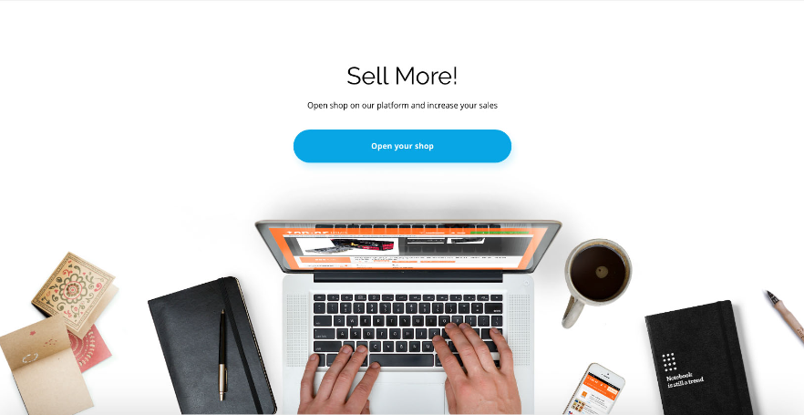

It consists of a heading (**h1**), a text (**p)** and a CTA (call to action) button, which is an appropriately styled **link**.

The background should be glued to the bottom of the section as an **img** element.

## Statistics

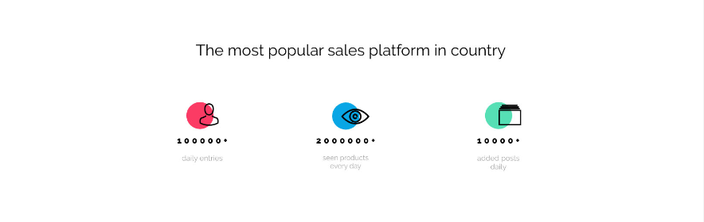

This section contains the heading **h2** and three columns with corresponding icons below it. Circles that are underneath the icons should be create in CSS and positioned appropriately – centrally to the cecnter of the vertical axis of the column.

## Benefits

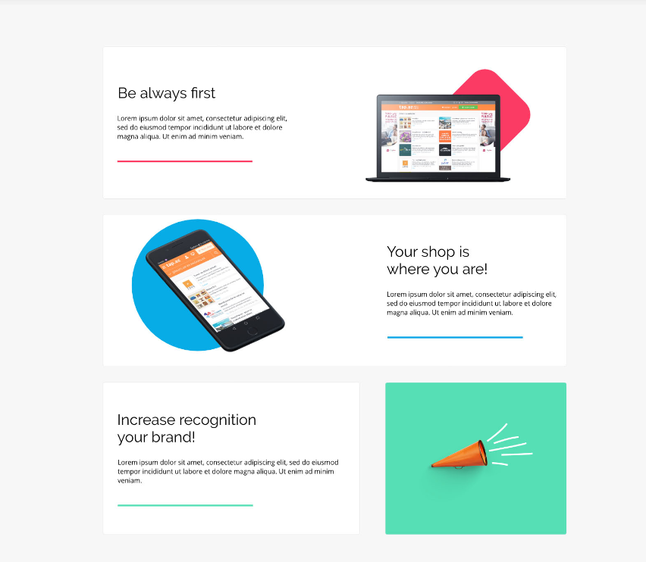

This section contains three rows of boxes. The picture and description appear alternately – an image is on the right, then below – on the left, then on the right again. The last row has an image separated form the text box. The background of this entire section is at 100% screen width, the rows themselves must fit into the appropriate container.

## Pricing

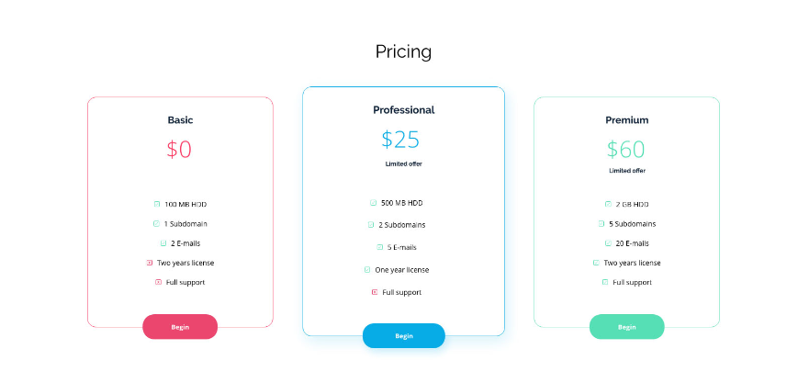

This is the most extensive section consisting of boxes in three columns. Each of them should get exactly the same style and then the **middle one should be highlighted**. The “Begin” buttons are appropriately styled **a** links. The lists in each column contain icons that should be placed on pseudo-elements **::before**.

## Contact

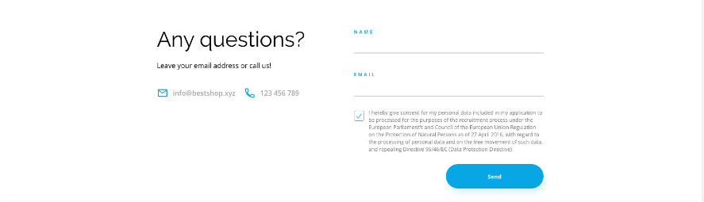

The section consists of two columns:

* left – header and short text and two additional columns with e-mail and phone icons
* right – a form with two text fields, one checkbox (custom-styled) and a “Send” button.

## Footer



The smallest section where there is only the company logo (as in section 1) and, on the other side, **links (a)** to Facebook and Twitter (they should be clickable).